**Seminar Report**

**On**

**Heath Based Food Recommendation Using ML**

**Submitted for partial fulfilment of requirements for the degree of**

Bachelor Of Engineering

In

Computer Science & Engineering

**Submitted By**

# Chandan Milan Majumdar

# Subodh R. Tirpude

# Sumit S . Jade

# Saurav U. Hingade

## Under the Guidance of Prof. C. R. Ingole

**Prof Ram Meghe College of Engineering and Management Badnera-Amravati**

**Department of Computer Science and Engineering**

**Sant Gadge Baba Amravati University, Amravati**

**2023-2024**

## CERTIFICATE

This is to certify that seminar work entitled “**Heath Based Food Recommendation Using ML**” is a bonafide work carried out in the Eight semester by **“Chandan Majumdar and Group**” in partial fulfilment for the award **of Bachelor of Engineering** in **Computer Science and Engineering** **from Prof Ram Meghe College of Engineering and Management Badnera-Amravati** during the academic year **2023-2024** under my guidance.

**Mr. C. R. Ingole Dr.D.G.Harkut**

Guide HOD, CSE

Assi. Professor Asso. Professor

Prof Ram Meghe College of Prof Ram Meghe College of

Engineering and Management Engineering and Management

Badnera-Amravati Badnera-Amravati

## 

## Dr. D.G. Harkut

Principal

**Prof Ram Meghe College of Engineering and Management Badnera-Amravati**

**Prof Ram Meghe College of Engineering and Management Badnera-Amravati**

**Department of Computer Science and Engineering**

**2023-24**

## ACKNOWLEDGEMENT

We would like to take this opportunity to acknowledge and express my gratitude to the individuals as well as department, all of whom were instrumental in the successful completion of my project seminar thanks to the assistance and direction they provided.

First of all, We would like to thank the **mentor Mr. C. R. Ingole** who served as a guide throughout the course of the procedure as well as the duration of the time We spent completing my study. They were an incredible source of assistance, support, and ideas for us to draw upon during the entirely of the process of bringing a successful end to my project.

Being on the same line we express my deep sense of guidance **Dr.D.G.Harkut, Head of Department CSE**. Their roles in the improvement of the study are recognize because of the significant impact they had on the quality of the research. They devoted a considerable amount of their time in order to provide us with informative remarks regarding our work, and they encouraged me to keep putting in my best effort in order to bring the project to a successful completion as soon as possible.

Finally, We would like to thank **Dr. D.G.Harkut, Principal of our Collage** for providing necessary facility during the period of working on this seminar work.

Thanks, are in order to all the colleagues and friends who knowingly or unknowingly helped us during this work.

# Name: Chandan Milan Majumdar

# Subodh R. Tirpude

# Sumit S . Jade

# Saurav U. Hingade

**Class:** Final Year

**Department:** Computer Science & Engineering

**ABSTRACT**

Unhealthy dietary choices contribute significantly to the burden of chronic diseases. To address this, machine learning (ML) holds immense potential for personalized health-based food recommendations. This paper explores the application of ML in crafting dietary plans tailored to individual needs and preferences, considering relevant health parameters. We highlight various approaches utilized in health-based food recommender systems, including content-based filtering, collaborative filtering, and hybrid techniques. Each approach leverages different data sources, such as: Nutritional information: Macronutrients, micronutrients, calories, and other dietary components of food items. User profiles: Dietary restrictions, allergies, preferences, health conditions, and goals. Medical data: Blood sugar levels, cholesterol levels, and other relevant markers. The abstract then discusses the challenges and ethical considerations associated with deploying such systems, emphasizing the importance of user privacy, data accuracy, and ensuring accessibility for diverse populations. Finally, the abstract concludes by outlining the potential impact of ML-powered food recommendations on promoting healthy eating habits, preventing chronic diseases, and empowering individuals to take control of their dietary choices for optimal health.

**Keywords**

Ethical Machine Learning, Responsible Data Science, Health Data Analytics, Food Science, Personalized Nutrition, Dietary Guidance, Chronic Disease Prevention, Public Health. User Preferences, Dietary Restrictions, Allergies, Health Goals, Medical Conditions, Nutritional Information

**LIST OF FIGURES**

|  |  |  |
| --- | --- | --- |
| **Figure No.** | **Title** | **Page No.** |
| 1.1 | System Architecture | 3 |
| 1.2 | System Workflow | 3 |
| 1.3 | Random Forest Algorithm | 5 |
| 1.4 | Proposed Model (Tentative) | 4 |
| 1.5 | Personalized Dietary Guidance | 9 |
| 1.6 | Nutritional Optimization | 10 |
| 1.7 | Improved Dietary Adherence | 10 |
| 1.8 | Enhanced Meal Planning | 12 |
| 1.9 | Nutritional Deficiency Detection | 12 |
| 2.1 | Pregnancy & Lactation Support | 13 |
| 2.2 | Sustainable Food Choices | 14 |
| 2.3 | Restaurant Meal Selection | 15 |

**LIST OF ACRONYMS**

|  |
| --- |
| **ML:** Machine Learning |
| **TDEE:** Total Daily Energy Expenditure |
| **BMI:** Body Mass Index |
| **BMR:** Basal Metabolic Rate |
| **GUI:** Graphical User Interface |
| **NumPy:** Numerical Python |
| **SVM:** Support Vector Machines |
| **API:** Application Programming Interface |
| **DLW:** Doubly Labelled Water Technique |
| **PAL:** Physical Activity Level |
| **Kcal:** Kilo Calories |
| **TEF:** Thermic Effect Of Food |

**CONTENTS**

|  |  |  |
| --- | --- | --- |
| **Chapter No.** | **Title** | **Page No.** |
|  | *Certificate* | *ii* |
|  | *Acknowledgement* | *iii* |
|  | *Abstract* | *iv* |
|  | *List of Figures* | *v* |
|  | List of Tables | vi |
|  | List of Acronyms | vii |
| 1 | **INTRODUCTION**   * 1. Content based Filtering Method   2. Collaborative based Filtering Method   3. Hybrid based Filtering Method |  |
| 2 | **SYSTEM ARCHITECTURE** |  |
| 3 | **SYSTEM WORKFLOW** |  |
| 4 | **PROPOSED WORK**   * 1. Machine Learning   2. Header files used   3. Applying Random Forest Classifier   4. Creating Interface   5. Taking Input: |  |
| 5 | **IMPLEMENTATION PROCEDURE** |  |
| 6 | **6. ADVANTAGES AND DISADVANTAGES**   * 1. Advantages   6.2 Disadvantages |  |
| 7 | **APPLICATION OF ML Model** |  |
| 8 | **Work distribution** |  |
| 9 | **FUTURE SCOPE** |  |
| 10 | **conclusion** |  |
| 11 | **REFERENCES** |  |

1. **INTRODUCTION**

One of the major factors for a healthy life is daily diet and food, specifically, for the people suffering from some minor or major diseases. eHealth initiatives and research efforts aim to offer various pervasive applications for novice end users to improve their health. Various studies depict that inappropriate and inadequate intake of diet is the major reasons of various health issues and diseases. A study conducted by World Health Organization (WHO) estimates that around 30% of the total population of the world is suffering from various diseases, and 60% deaths each year in children are related to malnutrition. Another study by WHO reports that inadequate and imbalanced intake of food causes around 9% of heart attack deaths, about 11% of ischemic heart disease deaths, and 14% of gastrointestinal cancer deaths worldwide. Moreover, around 0.25 billion children are suffering from Vitamin-A deficiency, 0.2 billion people are suffering from iron deficiency (anemia), and 0.7 billion people are suffering from iodine deficiency. The main focus of this work is to provide dietary assistance to different people who are suffering from common diseases or maybe no diseases. A recommender system, or a recommendation system (sometimes replacing 'system' with a synonym such as platform or engine), is a subclass of [information filtering system](https://en.wikipedia.org/wiki/Information_filtering_system) that seeks to predict the "rating" or "preference" a user would give to an item. They are primarily used in commercial applications.

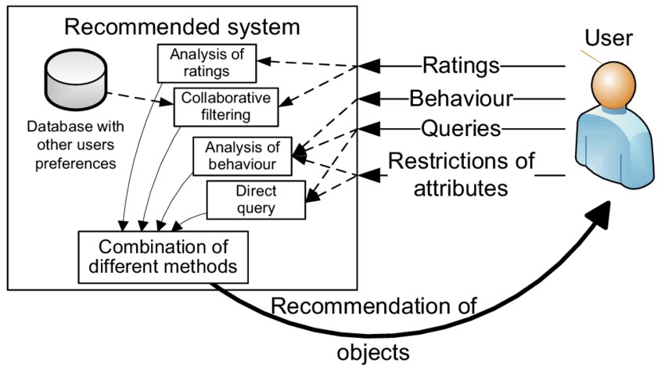

The recommendation process has basically three stages that are Information Collection Phase, Learning Phase and Recommendation Phase. The information is firstly collected about a particular problem and the various solutions related to that problem are categorized. After the collection of information Learning Phase comes in which various conclusions are made out of that information which is gathered and in last phase i.e. Recommendation Phase an output is given in which various recommendations are made. In our system since it is a diet recommendation system so the recommendations will be about the diet plan like what all things you should eat, what is your BMI (Body Mass Index) which states whether you are healthy, overweight, or under-weight.

**Techniques used for building a Recommendation System-**

* 1. **Content based Filtering Method -** The content-based method is a domain-dependent algorithm which focuses on much more on the evaluation of the characteristics of things to produce predictions. When files like pages, publications as well as news are being suggested, the content-based filtering strategy is probably the most profitable. In a content-based filtering technique, the suggestion is made based upon the person profiles with features obtained from the information in the things the person has examined in previous times.
  2. **Collaborative based Filtering Method-** Collaborative filtering is a domain-independent prediction technique for content that cannot easily and adequately be described by metadata such as movies and music. Collaborative filtering technique works by building a database (user-item matrix) of preferences for items by users. In the newer, narrower sense, collaborative filtering is a method of making automatic [predictions](https://en.wikipedia.org/wiki/Prediction) (filtering) about the interests of a [user](https://en.wikipedia.org/wiki/End_user) by collecting preferences or [taste](https://en.wikipedia.org/wiki/Taste_(sociology)) information from [many users](https://en.wikipedia.org/wiki/Crowdsourcing) (collaborating). The underlying assumption of the collaborative filtering approach is that if a person *A* has the same opinion as a person *B* on an issue, A is more likely to have B's opinion on a different issue than that of a randomly chosen person. 
     1. **Memory based Filtering Method-** The items that have been previously rated by the user before play a pertinent part in looking for a neighbor that shares appreciation with him. When a neighbor of a person is found, various algorithms could be utilized combining the tastes of friends to produce recommendations. Because of the usefulness of these strategies, they've accomplished extensive results in real-life applications.
     2. **Model based Filtering Method-** In this approach, models are developed using different [data mining,](https://en.wikipedia.org/wiki/Data_mining) [machine learning](https://en.wikipedia.org/wiki/Machine_learning) algorithms to predict users' rating of unrated items. There are many model-based CF algorithms.Bayesian network[s,](https://en.wikipedia.org/wiki/Bayesian_networks)clustering model[s,](https://en.wikipedia.org/wiki/Cluster_Analysis)latent semantic [models](https://en.wikipedia.org/wiki/Latent_Semantic_Indexing) such assingular value decompositio[n,](https://en.wikipedia.org/wiki/Singular_value_decomposition)probabilistic latent [semantic analysis,](https://en.wikipedia.org/wiki/Probabilistic_latent_semantic_analysis) multiple multiplicative factor,latent Dirichlet [allocation](https://en.wikipedia.org/wiki/Latent_Dirichlet_allocation) and [Markov decision process](https://en.wikipedia.org/wiki/Markov_decision_process) based models.

* 1. **Hybrid based Filtering Method-** A number of applications combine the memory-based and the model-based CF algorithms. These overcome the limitations of native CF approaches and improve prediction performance. Importantly, they overcome the CF problems such as sparsity and loss of information. However, they have increased complexity and are expensive to implement. Usually most commercial recommender systems are hybrid, for example, the Google news recommender system.

1. **SYSTEM ARCHITECTURE:**

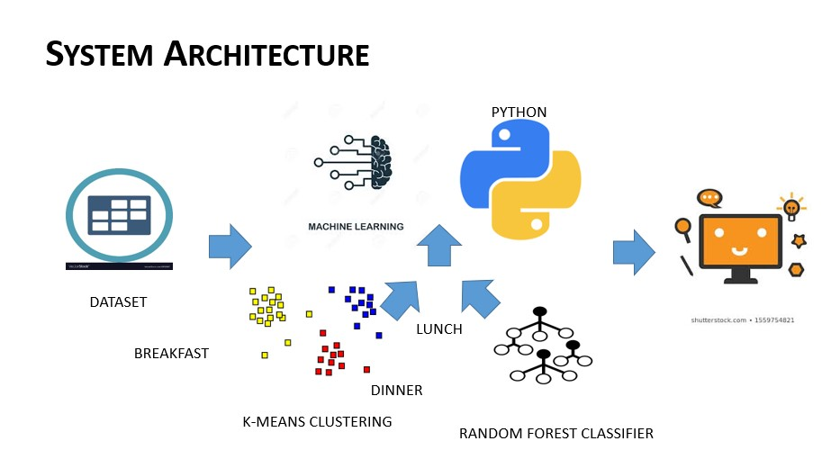



**Fig:1.1 SYSTEM ARCHITECTURE**

1. **SYSTEM WORKFLOW:**

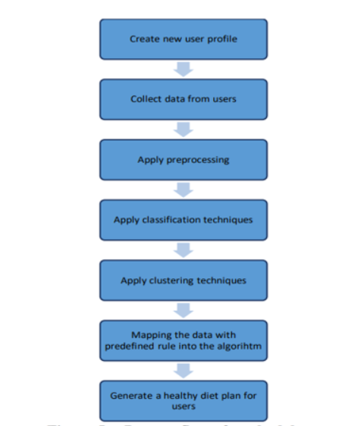

**Fig:1.2 System Workflow**

1. **Algorithm Used :**

Random forest is a commonly-used **machine learning algorithm** trademarked by Leo Breiman and Adele Cutler, which combines the output of multiple decision trees to reach a single result. Its ease of use and flexibility have fueled its adoption, as it handles both classification and regression problems.

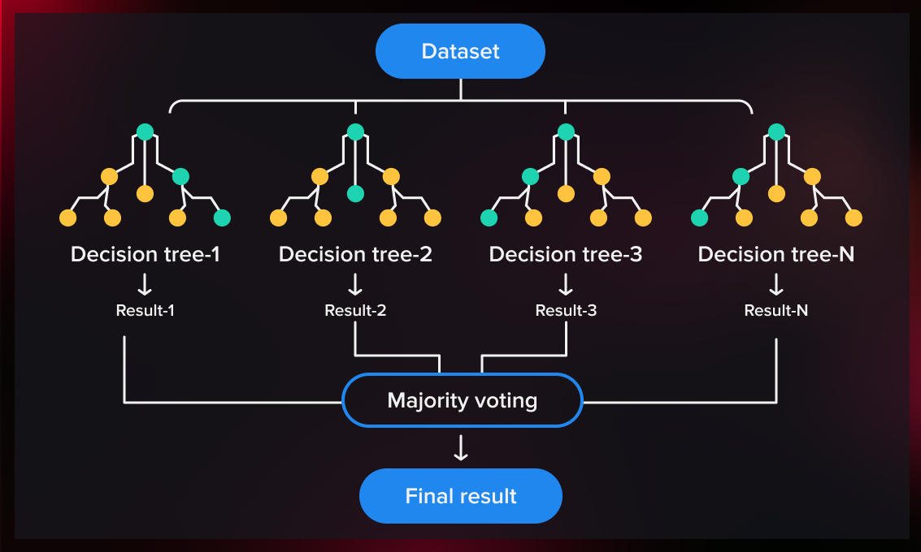

**Fig:1.3 Random Forest Algorithm**

1. **PROPOSED WORK:**

**4.1** This project has been developed using Machine Learning algorithms. Random Forest Classifier is used to classify the food items and predict the food items based on input given.

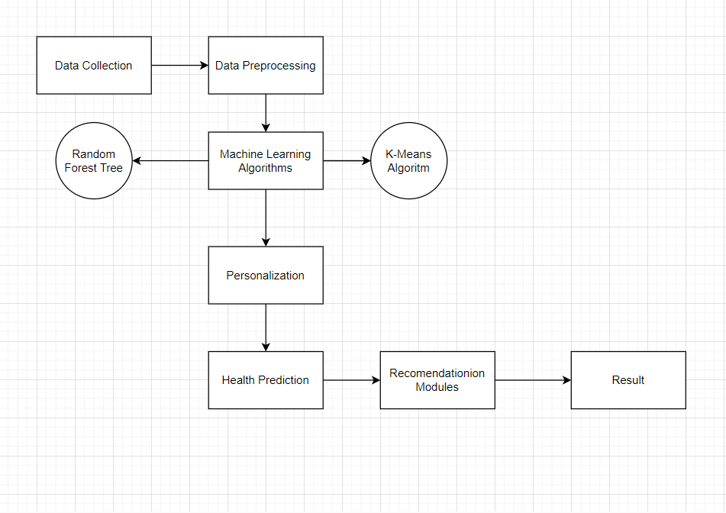

**Fig:1.4 Proposed Model (Tentative)**

**4.2 Header files used:**

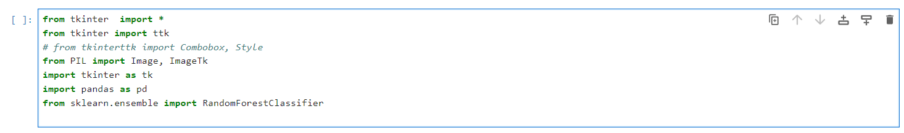

Pandas was used to read datasets.

Numpy was used to convert features into numpy and then perform the further operations.

Tkinter was used to create interface.

RandomForestClassifier used to predict the food items based on clustered data.

**4.3 Applying Random Forest Classifier:**

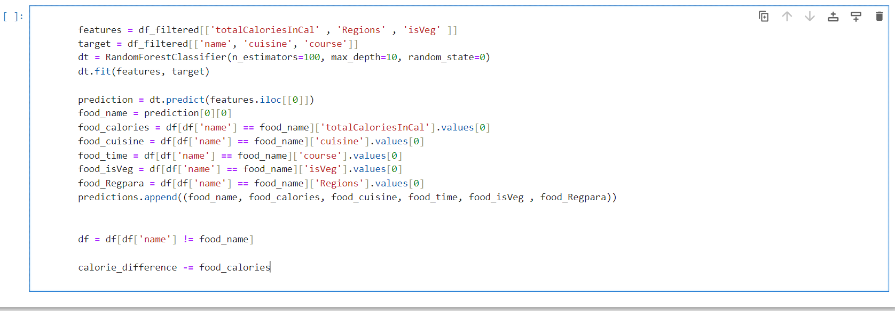

**4.4 Creating Interface:**

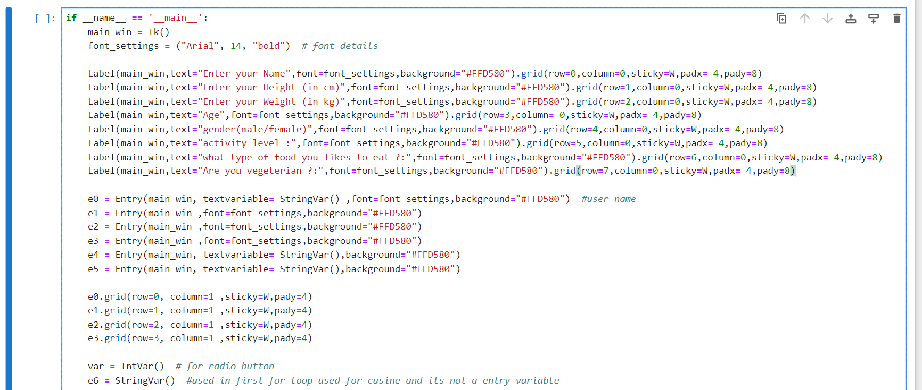

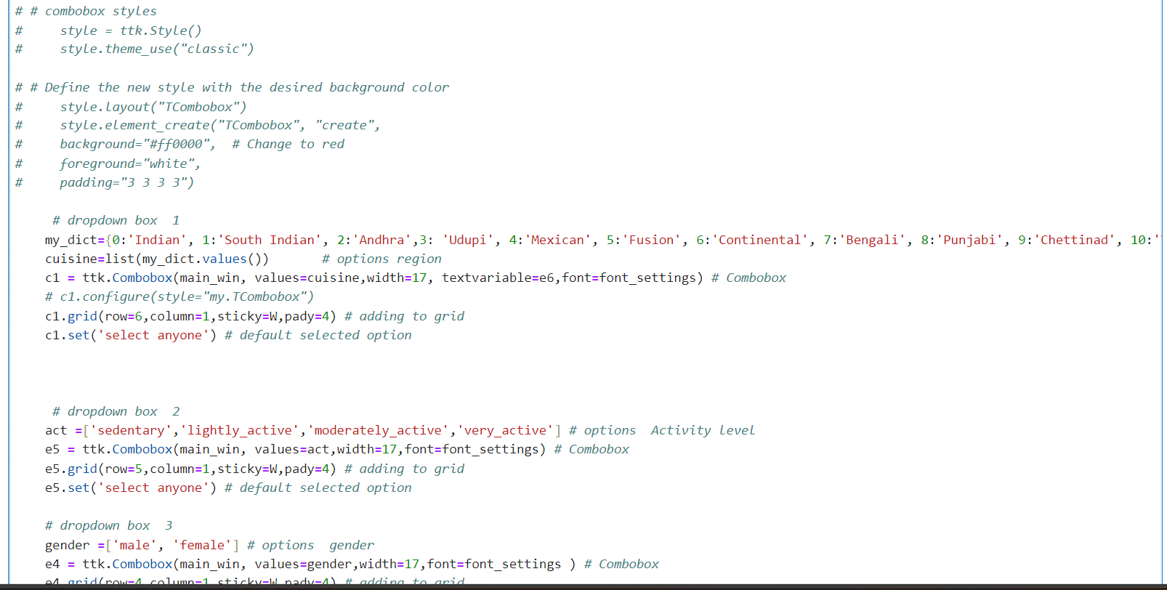

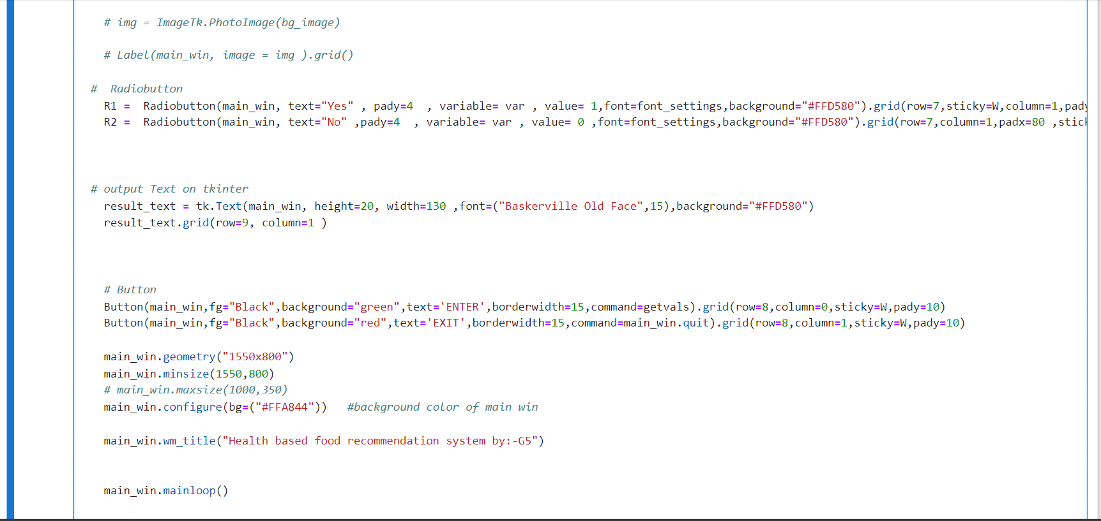

**4.5 Taking Input:**

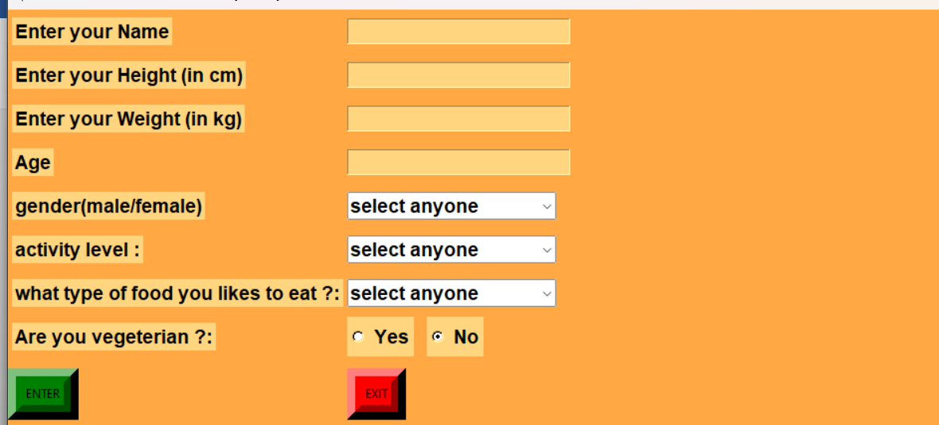

**4.6 Predicting Food items for Weight Loss Diet Plan:**

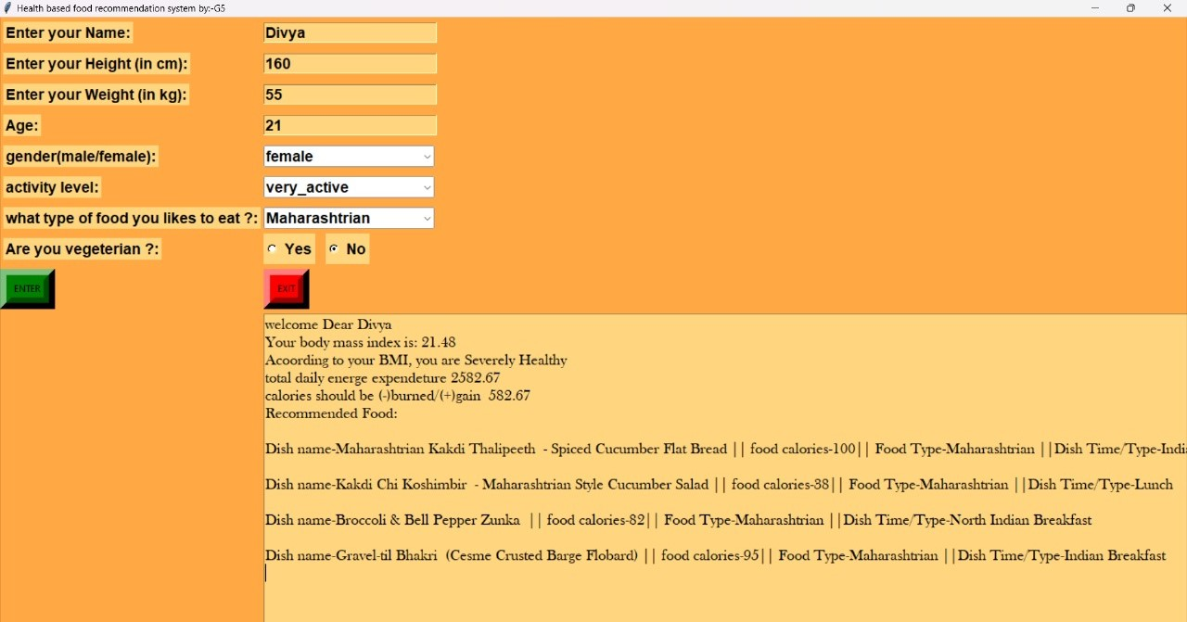

**4.7 Predicting Food Items for Weight Gain Diet Plan:**

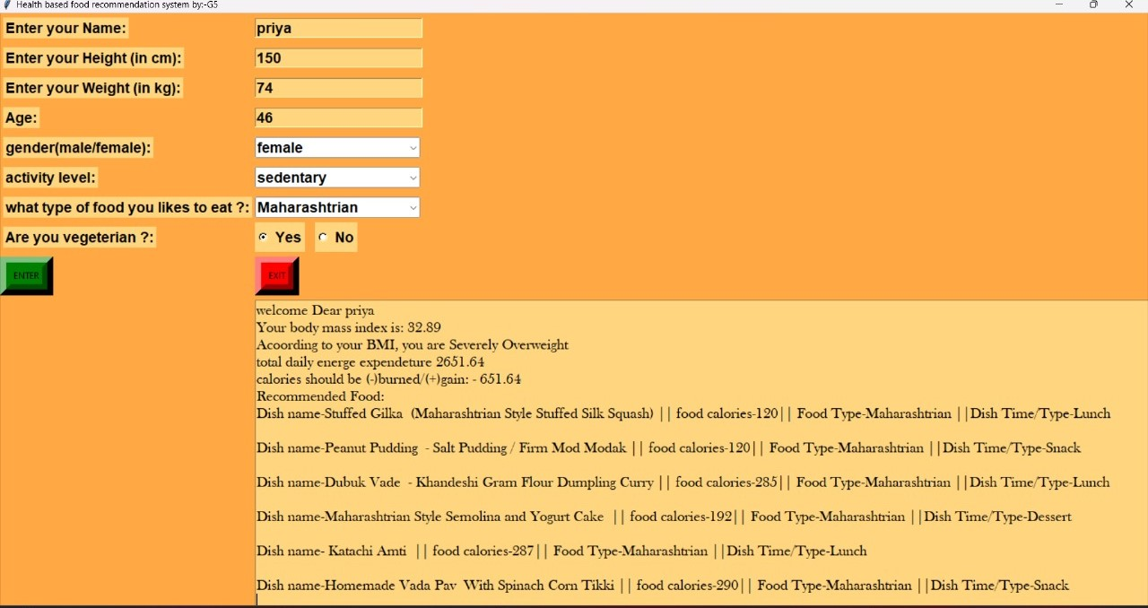

**5. IMPLEMENTATION PROCEDURE:**

Building a diet recommendation system using machine learning involves several steps. Below is a high-level implementation procedure for creating such a system. Please note that this is a generalized guide, and the specific details may vary based on your data, goals, and the machine learning algorithms you choose.

1. Define the Problem and Objectives:

Clearly define the problem you want to solve with the diet recommendation system.

Specify the objectives and goals of the system, such as weight loss, muscle gain, or overall health improvement.

2. Gather Data:

Collect relevant data for training your machine learning model. This may include:

User profiles (age, gender, weight, height, activity level, medical conditions).

Dietary preferences and restrictions.

Food items with nutritional information (calories, macronutrients, vitamins, etc.).

3. Preprocess the Data:

Clean and preprocess the data to handle missing values, outliers, and inconsistencies.

Transform categorical variables (e.g., food preferences) into numerical representations.

Normalize or scale numerical features to ensure consistency in the data.

4. Feature Engineering:

Extract relevant features from the data that can help the model make accurate predictions.

Consider creating new features or combining existing ones to enhance model performance.

5. Model Selection:

Choose an appropriate machine learning model for your diet recommendation system. Common models include:

Decision trees

Random forests

Support Vector Machines (SVM)

Neural networks.

6. Train the Model:

Split the dataset into training and testing sets.

Train the machine learning model using the training data.

Fine-tune hyperparameters to optimize the model's performance.

7. Evaluation:

Evaluate the model's performance using the testing dataset.

Metrics such as accuracy, precision, recall, and F1 score can be used to assess the model's effectiveness.

8. Integration:

Implement the model into the diet recommendation system.

Develop a user interface or API through which users can input their information and receive personalized diet recommendations.

9. Continuous Improvement:

Monitor the system's performance over time.

Collect user feedback and update the model periodically to improve its accuracy and relevance.

10. Privacy and Security:

Implement measures to ensure user privacy and the security of their personal data.

Comply with relevant data protection regulations.

11. Deployment:

Deploy the diet recommendation system to a production environment, making it accessible to users.

12. User Feedback Loop:

Encourage users to provide feedback on the recommendations and use this feedback to continuously improve the system.

13. Maintainability:

Regularly update the system to adapt to changing dietary guidelines, user preferences, and new research findings.

**6. ADVANTAGES AND DISADVANTAGES:**

**6.1 Advantages:**

**1**. Personalized Dietary Guidance: ML algorithms can analyze a user's health data (age, medical conditions, allergies, fitness goals) and dietary preferences to recommend foods tailored to their specific needs. This fosters healthier eating habits and promotes disease prevention.

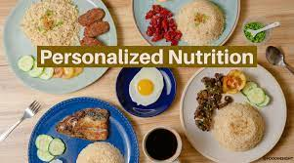

**Fig:1.5 Personalized Dietary Guidance**

1. Nutritional Optimization: ML models can assess a user's current dietary intake and suggest foods to address nutritional deficiencies or imbalances. This ensures users are getting the essential vitamins, minerals, and macronutrients for optimal health.

**Fig:1.6 Nutritional Optimization**

**3**. Improved Dietary Adherence: Personalized recommendations increase the likelihood of users adopting and sticking to dietary changes prescribed by healthcare professionals or chosen for personal goals. This can lead to sustained improvements in health outcomes.

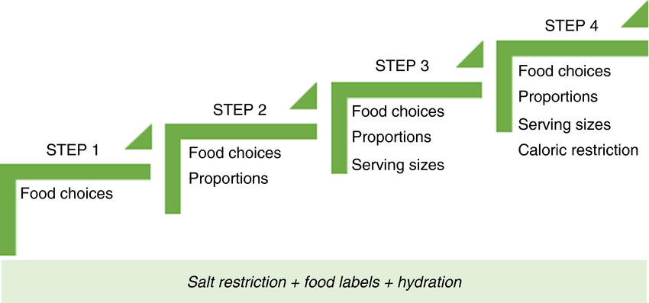

**Fig:1.7 Improved Dietary Adherence**

**4**. Enhanced Meal Planning: ML-powered systems can generate meal plans that factor in dietary restrictions, preferences, and budget constraints. This simplifies meal planning for individuals with busy schedules or those managing multiple dietary needs.



**Fig:1.8 Enhanced Meal Planning**

**5**. Discovery of New and Healthy Options: ML algorithms can recommend healthy alternatives to user-favoured unhealthy foods, helping them expand their palates and explore nutritious options they might not have considered before.

**6**. Trend and Recipe Recommendation: ML can analyse food trends, user demographics, and recipe data to suggest trending and popular healthy recipes in line with personal preferences. This fosters culinary creativity and keeps mealtimes exciting.

**7**. Dietary Management for Chronic Conditions: For individuals with chronic conditions like diabetes or heart disease, ML-based recommendations can assist in managing their nutritional needs effectively, potentially reducing complications and improving well-being.

**8.** Reduced Food Waste: By recommending personalized meal plans and suggesting creative ways to use leftovers, ML can help users minimize food waste. This contributes to sustainability and reduces the environmental impact of food production.

**9**. Data-Driven Insights for Food Industry: Insights gleaned from user data and food choices can inform food manufacturers and retailers about consumer preferences, nutritional needs, and emerging trends. This allows them to develop and market healthier food options that align with consumer demand.

**10**. Continuous Improvement and Learning: ML models constantly learn and evolve as user data accumulates. This ensures recommendations become more accurate and personalized over time, leading to ongoing improvements in user health and satisfaction.

**6.2 Disadvantages :**

**1.** Limited data: ML models rely on training data, and biases within that data can be amplified. If the data lacks diversity in demographics, health conditions, or food preferences, recommendations could be unfair or inaccurate for certain groups.

**2.** Confirmation bias: Users tend to choose foods they already enjoy or agree with, reinforcing the algorithm's bias towards those choices. This can create echo chambers and limit exposure to new, potentially healthier options.

**3.** Overfitting: Models trained on specific datasets may not generalize well to new situations or individuals. This can lead to inaccurate recommendations for users with unique dietary needs or preferences.

**4.** Black box problem: Understanding how the ML model arrives at its recommendations can be difficult, making it hard to interpret or explain choices to users, potentially affecting trust and adherence.

**5**. Misinterpretation: Users may misinterpret recommendations or overemphasize individual nutrients over balanced diets, leading to unhealthy fixations or restrictive eating patterns.

**6**. Privacy risks: Food tracking and health data used for training models raise privacy concerns. Clear data security protocols and user consent are crucial.

**7.** Accessibility and affordability: ML-based systems may not be accessible to everyone due to technological limitations, cost, or lack of internet access, exacerbating existing health disparities.

**8.** Commodification of health: Reducing food choices to data points and algorithms can devalue the cultural and emotional aspects of eating, potentially leading to a medicalized and restrictive relationship with food.

**9.** Overreliance on technology: Dependence on ML recommendations can diminish individual understanding of healthy eating principles and the ability to make informed choices independently.

**10.** Economic impact: ML-driven food recommendations could unfairly Favor certain food industries or products, affecting local economies and sustainable food practices.

**7. APPLICATION OF ML Model :**

**1.** Personalized Diet Plans: Analyze users' health data (medical conditions, allergies, fitness goals) and food preferences to suggest personalized meal plans that meet their nutritional needs and dietary restrictions.

**2**. Chronic Disease Management: Develop systems for individuals with chronic illnesses like diabetes, heart disease, or obesity. Recommend recipes and meal plans tailored to manage their specific condition and improve health outcomes.

**3**. Food Allergy & Intolerance Assistance: Assist individuals with food allergies or intolerances by identifying safe and suitable food options based on their specific needs.

**4.** Nutritional Deficiency Detection & Prevention: Analyze users' dietary intake data to identify potential nutritional deficiencies and recommend foods rich in specific nutrients to prevent health problems.



**Fig 1,9 Nutritional Deficiency Detection**

**5**. Weight Management & Portion Control: Provide recommendations for weight loss, maintenance, or gain based on users' goals and activity levels. Suggest portion sizes and healthy alternatives to promote balanced eating.

**6.** Pregnancy & Lactation Support: Design meal plans for pregnant and lactating women to ensure adequate intake of essential nutrients for both mother and child. Include recommendations for foods to avoid during these stages.



**Fig 2.1 Pregnancy & Lactation Support**

**7.** Post-Surgery Recovery: Recommend foods and meal plans to support optimal healing and recovery after surgery, considering specific dietary needs and restrictions.

**8**. Mental & Emotional Wellbeing: Explore the connection between food and mental health. Develop systems that suggest foods to promote mood regulation, stress reduction, and cognitive function.

**9.** Sustainable Food Choices: Recommend environmentally friendly and ethically sourced food options based on users' preferences and dietary needs. Promote sustainable food practices and reduce environmental impact.

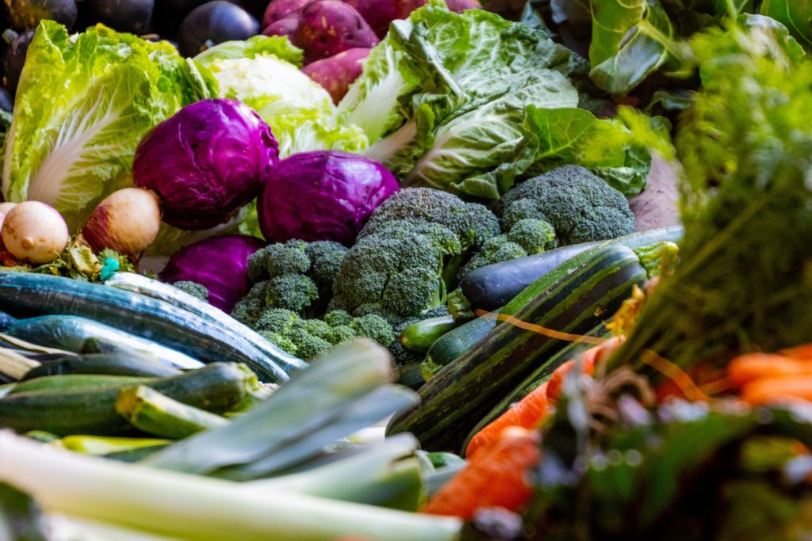

**Fig 2.2 Sustainable Food Choices**

**10.** Food Waste Reduction: Analyze user data and buying habits to offer personalized recommendations that minimize food waste, suggest creative recipe ideas for leftovers, and promote optimal storage practices.

**Bonus Applications:**

Restaurant Meal Selection: Help users with dietary restrictions or specific health goals make informed choices when dining out.



**Fig 2.3 Restaurant Meal Selection**

Grocery Shopping Assistanance: Develop smart shopping lists based on individual needs and preferences, helping users make healthy and budget-friendly choices. Dietary Education & Coaching: Integrate educational tools and coaching mechanisms into food recommendation systems to promote long-term healthy eating habits.

**8. Work distribution**

|  |  |
| --- | --- |
| Module | Member |
| Backend Work | Chandan Majumdar |
| Dataset And Supportive Work  (Group Leader) | Subodh Tirpude |
| Graphical User Interface (GUI) | Sumit Jade |
| Research And Supportive Work | Sourav Hingade |

**9. FUTURE SCOPE:**

1. The module can be implemented as a cloud-based application.
2. Predictive Nutrition and Disease Prevention.
3. Food Waste Reduction and Sustainability.
4. Culturally Sensitive Recommendations.
5. Addressing Food Intolerances and Allergies.
6. Supporting Children's Healthy Eating Habits.
7. Addressing Food Deserts and Nutritional Inequalities.
8. Promoting Mental and Emotional Well-being through Food.
9. Food Traceability and Transparency.
10. Combating Food Misinformation and Fad Diets.
11. Education and Empowerment through Food Recommendations.
12. Open-source Food Data and Recommendation Systems.
13. Addressing Ethical Concerns and Data Privacy.
14. Packaged as a single entity, ready for production environment deployment.

**10. conclusion**

In conclusion, while challenges exist, the potential of ML-powered health-based food recommendation systems is significant. By addressing data, privacy, and accessibility concerns, these systems can empower individuals to make informed dietary choices and support their health journeys. Future research and development efforts should focus on refining existing models, addressing challenges, and exploring new avenues to maximize the impact of these systems on public health and well-being.

**11. REFERENCES**

1) Mifflin MD, St Jeor ST, Hill LA, Scott BJ, Daugherty SA, Koh YO. A new predictive equation for resting energy expenditure in healthy individuals; The American Journal of Clinical Nutrition; February 1990

2) Harris JA, Benedict FG. A Biometric Study of Human Basal Metabolism.; The Proceedings of the National Academy of Sciences (PNAS); 1918

3) McArdle WD, Katch FI, Katch VL. Exercise Physiology – Energy, Nutrition and Human Performance.; Journal of Physical Therapy Education; 2001

4) Schofield WN. Predicting basal metabolic rate, new standards and review of previous work; Human nutrition : Clinical nutrition; 1985

5) Roza AM, Shizgal HM. The Harris Benedict equation reevaluated: resting energy requirements and the body cell mass.; The American Journal of Clinical Nutrition; July 1984

6) Mrs. N. Naga Lakshmi, M. Jagadeesh Reddy, K. Hari Krishna, S. Sindhuja Reddy. Vitamin Deficiency and Food Recommendation System Using Machine Learning.; International Journal for Research in Applied Science & Engineering Technology (IJRASET);

[7] Shubham Singh Kardam, Pinky Yadav, Raj Thakkar, Prof Anand Ingle, “Website on Diet Recommendation Using Machine Learning”, International Research Journal of Engineering and Technology (IRJET), vol.8, 2021, p-ISSN: 2395-0072.

[8] Salliah Shafi Bhat and Gufran Ahmad Ansari, “Predictions of Diabetes and Diet Recommendation System for Diabetic Patients using Machine Learning Techniques”, International Conference for Emerging Technology (INCET), 2021, Belagavi, India, pp. 1-5, doi: 10.1109/INCET51464.2021.9456365.

[9] S. V. N. Sreenivasu, Sakshi Gupta, Ghanshyam Vatsa And Anurag Shrivastava, “Carbohydrate Recommendation for Type-1 Diabetics Patient Using Machine Learning”, 5th International Conference on Contemporary Computing And Informatics, UP, 2022, pp. 600-604, doi: 10.1109/IC3I56241.2022.10072919.

[10] Aryan Jalali, Kumar P. Arjun Manoj, N.Amulya, Ayesha Siddiqui, Alok Kumar Singh, S.M. Hari Krishna, “Mobile Application for Personalized Food Recommendation”, IEEE 7th International Conference for Convergence in Technology, Mumbai, 2022, pp. 1-6, doi: 10.1109/I2CT5491.2022.9824896.

[11]George A Bray, William E Heisel, Ashkan Afshin, Michael D Jensen, William H Dietz, Michael Long, Robert F Kushner, Stephen R Daniels, Thomas A Wadden, Adam G Tsai, Frank B Hu, John M Jackicic, Donna H Ryan, Bruce M Wolfe, Thomas H Inge, “The Science of Obesity Management: An Endocrine Society Scientific Statement”, Endocrine Reviews, 2018, vol: 39, doi: https://doi.org/10.1210/er.2017-00253.

[12]https://gist.githubusercontent.com/sukanyabag/fec853cee5c77ec362820e2131777911/raw/8438f 14bb7f48ba2f7dc8a7057e5bf23259a690a/LSTM.py